The Restorative Prison Project

Restorative Justice in HM Prison Holme House:
A Research Paper by Jennifer Dinsdale∗

FOREWORD
HM Prison Holme House is one of three Prisons in North East England which are participating in development work with the Restorative Prison Project. The Project is managed by the International Centre for Prison Studies and funded by Northern Rock Foundation.

Jennifer Dinsdale, an MSc student at Manchester Metropolitan University, undertook a piece of research at Holme House during the summer of 2001. The following report describes her findings. The conclusions provide helpful indicators for the continuing work of the Project and clear evidence of the interest and willingness of prisoners to be involved in restorative work.

Thanks are due to the Governor, Richard Crouch, and the Psychology Department at HM Prison for facilitating this research, and especially to Jennifer Dinsdale and her academic supervisors for their active interest in the important subject of Restorative Justice in a prison setting.

Anne Mace
Project Manager

CONTENTS

- Introduction 2
What is Restorative Justice?
The Restorative Prison Project

- Research Aims 2
Objectives

- Research Methodology 3
Sampling
Distribution & Collection Procedures
Scoring Methods – Questionnaires
Scoring Methods – Interviews
Analysis
Population Demographics

- Results- Prisoner Questionnaires 6

- Results – Prisoner Interviews 14

- Conclusions and Recommendations 16

- Summary 18

- References 18

Appendices
Appendix 1. Prisoner Questionnaire
Appendix 2. Prisoner Interview
INTRODUCTION

WHAT IS RESTORATIVE JUSTICE?
Restorative Justice is a very different way of viewing crime to the way we currently do.

The focus of the justice system today is the relationship between the offender and the state, where the state takes over the process from the victim (Bazemore, 1998).

In restorative justice the emphasis of the process is placed on the relationship between the offender and the victim (Mackay, 2001).

It is an approach to crime that understands it mainly as harm, and that seeks to respond by repairing this harm, rather than merely by processing and punishing offenders.

In doing this, a more balanced process and outcome are sought, with both the victim’s needs and the wider impact of crime on offender’s community being recognised and considered.

THE RESTORATIVE PRISON PROJECT
Restorative justice in prison is a relatively new concept and is primarily concerned with encouraging prisoners to take personal responsibility for their crimes by providing opportunities for them to make amends to victims and victimised communities (Mace, 2000).

In January 2000, the International Centre for Prison Studies (ICPS) embarked upon the Restorative Prison Project.

The project is investigating different models of integrating restorative approaches within prison regimes, which involve and benefit the local community.

Ultimately, the project is working towards applying such restorative justice principles within selected prisons in the North East, one of which is Holme House.

RESEARCH AIMS
Accordingly, the purpose of this report was to investigate the feasibility of introducing such Restorative schemes into Holme House with a particular focus on:

- Investigating prisoners perceptions of the impact of their crimes on their victims (including the wider community)
- Identifying the degree to which they would be ‘sympathetic’ to engaging in reparative activities and their motivations for doing so
- Establishing how important they feel it is to build a relationship with the community outside prison, and how important they feel their reconciliation with wider society actually is.

All of these were assessed in relation to individual offence types for comparison.

OBJECTIVES
- Are prisoner motivations strong enough to favour going ahead with restorative justice schemes within Holme House?
- What do prisoners think will be the anticipated effects and benefits of such schemes on themselves, the prison and the local community?

RESEARCH METHODOLOGY
Semi-structured questionnaires were the primary method used to obtain prisoner views on implementing such schemes into the prison, as they were deemed to be the most efficient way of obtaining a wide range of opinions in the time available.

Follow up semi-structured interviews were also devised and conducted on a much smaller scale to gather more in-depth information and to compare the main themes discussed with the kind of views obtained in the questionnaires.

SAMPLING
Using a LIDS printout of every prisoner in Holme House, each individual was sorted into a category according to his offence type, i.e. ‘burglary’, ‘robbery’ etc.. to produce 19 different offence categories.

In order to obtain the desired sample size of 200 prisoners, at least 10 people were needed in each category. However, because several of the groups didn’t contain this number those groups that had under 10 were all included in the sample, and those categories that had 10 or more had an equal number of extra subjects randomly taken from their particular group and added to the overall sample in order to reach the target.

Each prisoner was assigned a number and a random number generator on computer used to randomly select the individuals who were to receive questionnaires within each offence category.

DISTRIBUTION & COLLECTION PROCEDURES
Once selected, enveloped questionnaires were delivered to each inmate with an enclosed envelope marked ‘Return to Psychology’ to ensure confidentiality.

Three days were given for the completion of the questionnaires, which were collected by the psychology department.

200 questionnaires were distributed to prisoners, which reflects a population sample base of approximately 24%.
110 completed questionnaires were returned – a return rate of 55%.

SCORING METHODS – QUESTIONNAIRES
The structured questions from the returned questionnaires were scored on a ‘Yes = 1’ and ‘No = 0’ basis.

Any that were open ended were content analysed, scored and all the results totalled.

Aside from demographics, all the questions were assessing different aspects of restorative justice (RJ) including victim awareness, willingness to participate in RJ schemes and individual reasons behind their willingness to get involved.

Any question where it was possible to answer with more than one response was analysed differently according to the aspect of RJ being assessed.

SCORING METHODS – INTERVIEWS
Individual responses to the interview questions were grouped together and ranked where possible, to produce categories of like answers that could then be scored. This would allow for direct numerical comparisons to be made with the questionnaire data.

The 15 interview questions assessed the following aspects of RJ,

- Victim Awareness
- Relationship with the community
- Willingness to participate in RJ schemes
- Individual motivations behind willingness to get involved
- Understanding of the aims & purposes behind RJ.

ANALYSIS
Basic analysis was carried out on the results to produce frequencies and percentages for all the questions in both the questionnaire and the interviews. The statistical package SPSS was used to provide more in depth information on the data where appropriate.

POPULATION DEMOGRAPHICS
The average age of respondents was 30, ranging from 21 – 61 years.

78% of prisoners in the sample were aged 21-35, 18% were 36-50 and 4% were 50+. 27% of prisoners reported that this was their first time in prison.

The diagram above shows the relative proportions of each offence type in the sample used.

The largest groups contained 12.7% of the sample and these were drug offences, robbery, burglary and driving offences.
Together these formed about 50% of the overall sample.

9 out of the 19 groups had up to 4 respondents and the categories ‘harassment’ and ‘threats’ had no respondents at all.

The average number of times subjects in the sample reported being imprisoned previously is 4.5, ranging from 0 to 24 times.

Figure 2 represents the time prisoners in the sample have left to serve. As the graph shows, the majority of prisoners who returned the questionnaires were serving sentences less than one year in duration.

In fact, there was found to be a statistically negative correlation between current sentence length and returned questionnaires (Spearman’s rho = -. 671). In other words, as sentence length increases, the number of returned questionnaires drops.

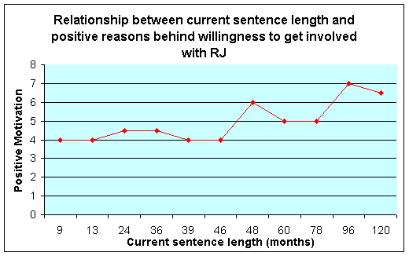

Below is a set of tables outlining all the percentage responses to the items in the questionnaire.

Q 2 Is this your first time in prison?
Yes 26.36%
No 73.64%

Q 5 Part A Do you think anyone was affected by
your offence?
Yes 90.91%
No 9.09%

Part B If so, who?
An individual 26.15%
An individual’s family 19.27%
Your own family / friends 40.37%
The local community 14.22%
Q 6 Do you think that the effects were
Physical 21.26%
Emotional 51.72%
Financial 27.01%

Q 7 Do you regret the effects the effects your crime had on
these people?
Yes 89.11%
No 10.89%

Q 8 Would you like the opportunity to make up for some of the
harm done by your crime?
Yes 73.74%
No 26.26%

Q 9 Would you be willing to explain why you committed the
offence and the circumstances surrounding your
offending by either,

Part A Meeting those personally affected by your crime

Part B Meeting with other people who have been affected
by the type of offence you are in prison for?

Part A Part B
Yes 65.15% 74.29%
No 34.85% 25.71%
No. of subjects 66 70

Q 10 Would you be willing to write letters of apology to those
personally affected by your crime?
Yes 44.44%
No 55.56%

Q 11

Part A Would you be willing to participate in work in
prison which benefited the local community, such
as making things for people to use (e.g. park benches, wheelchairs etc.).

Part A Yes 87.16%
No 12.84%

Part B If yes, How do you think such work would benefit
you?

Part B Make me feel good 16.92%
Get me out of my cell 12.99%
Help me gain new skills 24.47%
Make me feel I was being useful 20.54%
It’d stop me being bored 9.06%
It’d look good on my record 8.16%
Any other reason 7.85%

Q 12 How important do you feel it is for Holme House to build a
relationship with the community outside?

Very important 50.46%
Quite important 28.44%
Not that important 13.76%
Not at all important 7.34%

Q 13 Do you think that doing work which helps the local
community would improve,

The atmosphere 24.46%
Good relations between staff & prisoners 36.41%
Relationships between yourself & other
prisoners 17.39%
Nothing about the atmosphere /
relationships in prison 8.15%
Other 13.59%

Q 14 If you fell out with another prisoner would you welcome
the opportunity to sit down with them and discuss the
problem in the presence of someone from outside prison
to try and resolve the situation?

Yes 37.04%
No 62.96%

There was a mixed response to the open ended questions added onto most of the questions above. These gave prisoners the opportunity to clarify the reasoning behind their responses and included probes like, How?’ or ‘Why do you feel as you do?’
Interestingly, there was quite a significant overlap in the kind of remarks made – to the extent that they could largely be grouped into response themes. These are summarised for some of the main questions below.

Q 9 – 53 did not comment at all on their willingness to meet either with their own victims of those of similar crimes, but overall the response of those that did comment was quite varied.
Those who were against either scenario commented that:

- ‘It’d be too awkward for me...’
- ‘I don’t think it’d achieve anything for me or the victim..’
- ‘Mine was a one-off crime and I’ll never do it again, so there’s no point..’
- Because I know the victim and it’d be too difficult to face them’

Generally, a high percentage of those sampled gave a favourable response to the suggestion that they meet with their victim (around 65%) and even more so to the idea that they meet victims of similar crimes (around 74%). It became clear from comments made that this was generally because it would ‘probably be less tense or embarrassing than meeting with personal victims’.

The largest proportion of prisoners who responded, (19%) said that they would like to ‘hear and understand how the victim was affected by what I did’ and interestingly, 3.5% reported having already met with their victim through the CPS.

Other comments included the following:

- ‘I’d like to say sorry..’
- ‘It might help me and the victim feel better..’
- ‘I want to explain it wasn’t personal..’
- ‘I’d try to tell them why I did it..’
- ‘It might help stop people offending again if they could see what they had put someone through..’

Q10. – 35 did not comment on their response to the suggestion that they write a letter of apology to those affected by their crime.

However, overall this was not regarded as a good idea by prisoners who did reply, with 55% admitting they would not be willing to do so. Of these the most common response was that they knew their victim, blamed them in some way for what happened and consequently were ‘not sorry’ (15%).

Other reasons included:

‘It would upset the victim..’
‘I wouldn’t know what to write..’
‘It wouldn’t change anything for them or me..’

Additionally 9.3% claimed they had already tried to write letters to victims and had had a negative response.

The largest proportion of those that thought the idea had potential felt that it would ‘allow them to apologise without risking angry confrontation from victims’..(36%).

Q11. Unfortunately, 73% of prisoners did not comment on their motivations for wanting to participate in restorative work but one third of those who did said that they would want to get involved because ‘it’d be a chance to put something back into the local community’.

The majority of the remainder (23%) said that they would be willing to do so if they felt that ‘it might give them skills to help gain employment on release’.

Q12. Only 16% thought that it was unimportant or not important at all for Holme House to build a relationship with the community, instead 33% of prisoners commented that it was essential in order ‘to help change the public’s perception of prisoners..’

Other popular responses included:

- ‘It could help prevent further offending and prepare us for our reintegration back into the community..’
- ‘It might make the community understand/increase awareness of what prison is like and how prisoners can be sorry and change..’
- ‘It would help inmates keep in touch with the reality of life outside..’

Figure 3 illustrates the overall average degree of willingness to get involved with RJ schemes across all the different offence types in Holme House.

Figure 3

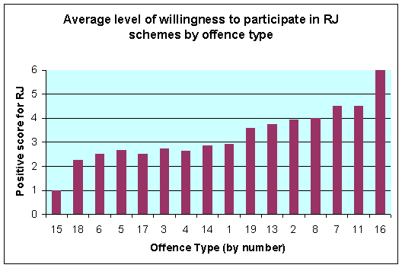

Clearly, offence group 16 (Death by Reckless Driving) responded most positively to the suggestion of prisoners getting involved with RJ whilst inside, with categories 7 (Kidnapping/Abduction) and 11 (Fraud), not far behind.

However these results are misleading in that these groups were amongst those with the smallest number of people in the sample. This means that outliers or ‘rogue’ results will more significantly affect any average response for the groups.

Therefore, the following graph was done to see if a prisoner’s time left to serve could be more accurately indicative of their motivation to participate in RJ schemes.

Figure 4

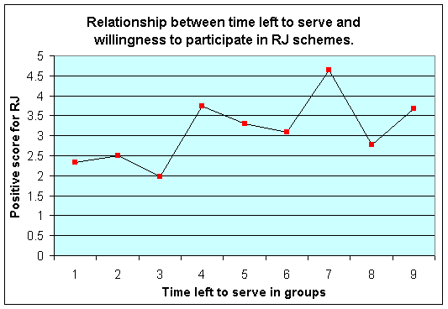

Statistical analysis using SPSS showed that there was definitely a positive correlation between a prisoners time left to serve and their willingness to get involved with RJ schemes (Spearman’s rho = 0.6). In other words, as time left to serve increases so does their overall motivation for RJ. This result could explain the preceding finding that those in offence group 16 were the most willing to get involved with RJ schemes, as they were indeed serving some of the longest sentences in the overall sample and generally had the most time left to serve.

The line graph below shows the link between a prisoner’s level of victim awareness and their motivation for getting involved with RJ initiatives.

Figure 5

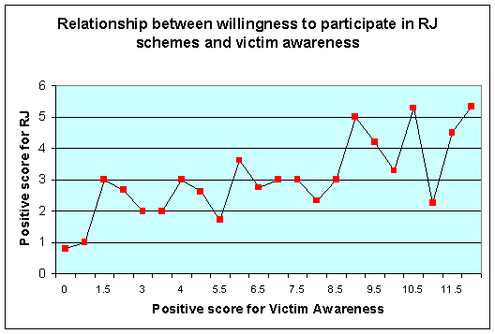

While the graph indicates that there appears to be a positive relationship between the two variables, statistical analysis confirmed that there was a strong positive correlation between victim awareness and motivation for RJ (Pearson’s r = .734).

Interview Results
Only 15 in depth interviews were conducted due to constraints on time and the requirements placed on separate analysis for the University.

Ordinarily, interviews could not be analysed quantitatively but for the purposes of this report similar responses for each interview question were grouped together and ranked on a scale according to the aspect of RJ being assessed, e.g. ‘Relationship with the community’ or ‘Victim awareness’ etc. Each group was then assigned a score according to their position within the ranking system.

Individuals were then given a score depending on which group their particular response fell into.

Figure 6

The graph shows that there is a significantly positive correlation between a prisoner’s current sentence length and their level of positive motivation for RJ. (Pearson’s r = .816)

In other words as overall sentence length increases, prisoner motivations for taking part in RJ schemes appear to become more genuine in this sample, and more what they ‘should’ be, i.e. not because it might ‘get them out of their cell’ or ‘stop them being bored’.

However, this finding should be viewed cautiously due to the small number interviewed and the fact that the interviews themselves would not normally be analysed in this way. For it to be more representative this would have to be reproduced on a larger scale.

Figure 7

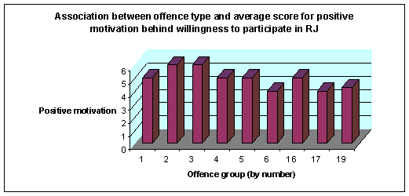

The interviews sampled 53% of the available offence types in Holme House, and as can be seen from figure 7 there doesn’t appear to be much variation in positive reasons behind prisoner willingness to participate in RJ schemes, with those from every offence type sampled scoring at least 50% on average overall.

However, again the sample size is too small to make conclusions based on this finding across the rest of the prison population, but nonetheless it is encouraging enough to warrant replicating on a wider scale to see if the effect is reproduced.

Also, there is a chance that those interviewed may have been dishonest and said what they thought would be wanted to be heard, rather than disclosing their true feelings in order to look better in front of the interviewer.

Finally it is worth noting that of those interviewed 93% scored highly for understanding the aims and purposes of RJ in prison, which contrasts strongly with what was found from the questionnaire analysis.

The majority of those prisoners who commented in favour of getting involved with RJ admitted that it would be useful if only to relieve boredom, get them out of their cell or give them a better prison record (38% average).

Again, either those interviewed could have simply been randomly enthusiastic about the ideas of RJ or the interview setting could have encouraged those interviewed to answer less truthfully; a more honest answer could be expected from the self completion questionnaire where their responses are anonymous and do not have to be justified.

Conclusions and Recommendations
On the whole, the questionnaire respondents did recognise that their offence had implications for innocent people, but interestingly, the greatest proportion of these felt that the only victim was their own family and friends, even when the nature of their offence made it clear that they were responsible for the direct victimisation of a specific individual, their family and the local community.

In line with this, statistical analysis showed that there was a strong link between prisoners having an awareness of the impact of their crimes on individuals and their willingness to get involved with RJ programmes whilst inside.

Recommendation 1
Taken together these findings strongly suggest that it would be worthwhile introducing victim awareness programmes on a larger scale throughout the prison so that more prisoners are afforded the opportunity to understand how their crimes affect others and take responsibility for their actions. It would seem logical that prisoner motivation for RJ would be more likely to develop if this were in place.

It was also found that as a prisoner’s time left to serve increases then so too does their willingness to participate in RJ programmes within prison, and more significantly, that the longer a prisoner’s current sentence the more their motivations behind wanting to get involved with RJ schemes improve.

This could be interpreted to mean that prisoners who are aware they will be staying inside for a long time have a different attitude to those who know they will soon be released, because they have had more time to think about their crimes and the consequences of these for others.

Consequently they seem more willing to be interested in getting involved with RJ programmes for the right sort of reasons and at present would appear to be the ideal groups to target for any trial RJ schemes.

Recommendation 2
These findings suggest that it would perhaps be worthwhile working on encouraging those serving the shortest sentences in Holme House, to put something back into the local community or to want to try and make amends to their victims (Statistically this would include all those serving 7 months or less).

Almost 80% of all prisoners considered Holme House building a relationship with the community to be important if not essential to help break down negative stereotypes, increase community awareness of what life in prison is really like, and aid their re-acceptance back into the local area upon release.

Recommendation 3
It would be worthwhile interviewing members of the local community to see what their perceptions of Holme House are, and what their attitude toward its community doing restorative work for the benefit would be.

This is necessary inasmuch as such work will probably only improve community relations when it has their full backing and support.

Finally, around 90% of prisoners expressed concern that any work done may not be credited specifically to themselves, which they feel would limit the capacity of restorative work to really change any negative opinions the community have of prisoners as a collective.

Recommendation 4
Therefore, it would be ideal for any future RJ work that is undertaken by the prison community to be well publicised within the local area giving recognition to those prisoners who have earned it.

By the prisoners’ own admission they feel that this will boost their self-esteem and self-worth which could prevent re-offending in the long-term.

SUMMARY
This report has shown that on the whole most prisoners are enthusiastic about the prospect of doing worthwhile work in prison.

Overall, 53% of prisoners who responded to the questionnaire and 72% of those who were interviewed were willing to get involved with any RJ work that benefited their victims, the local community and which helped them develop employable skills.

This is encouraging, and does indicate that it would be worthwhile introducing Restorative Justice into Holme House.

However, individual motivations behind this willingness have been shown to vary quite a lot and this is the area that requires some improvement if any programmes are going to be integrated into the prisoner regime successfully, and benefit both the community inside Holme House and that which is outside.

Jennifer Dinsdale
Manchester Metropolitan University
May – July 2001

REFERENCES
Bazemore, G (1998) ‘Restorative Justice and Earned Redemption: Communities, Victims, and Offender Reintegration’. American Behavioural Scientist, Vol. 41 No. 6 Pp. 768 – 813.

Mace, A (2000) Discussion Paper - Restorative Principles in the Prison Setting: A Vision for the Future. International Centre for Prison Studies.

Mackay, R.E (2001) ‘Restorative Justice, Punishment and Prisons’. The Prison Service Journal No. 135, Pp. 57 – 59.

APPENDIX 1

Please tick the appropriate box unless otherwise instructed

Q1 How old are you? ____________________________________

Q2 Is this your first time in prison?
Yes No
If NO:
How many times have you been in prison before this sentence?

___________________________________________________

What is the total amount of time you have served in prison, not including your current sentence?

Q3 What is the length of your current sentence and roughly how long
have you left to serve?

Current sentence __________________________________________

Time left to serve __________________________________________

Q4 Please indicate what you are in prison for now (e.g. Burglary)

______________________________________________________________

______________________________________________________________

Q5 Do you think that anyone was affected by your offence?

Yes No

If so, who? (Please tick more than one if needed)

An individual
An individuals Family
Your own Family/Friends
The local community

Q6 Do you think that the effects were:

(i) Physical?
(ii) Emotional?
(iii) Financial?

If so, HOW?
____________________________________________________________________________________________________________________________
Q7 Do you regret the effects your crime had on these people?

Yes No

Q8 Would you like the opportunity to make up for some of the harm
done by your crime?

Yes No

IF YES: Go to question 9
IF NO: Go to question 10

Q9 Would you be willing to explain why you committed the offence and
the circumstances surrounding your offending by either:

A Meeting with those personally affected by your crime?

Yes No

B Meeting with other people who have been affected by the type of
offence you are in prison for?

Yes No

WHY?
______________________________________________________________
______________________________________________________________

Q10 Would you be willing to write letters of apology to those personally
affected by your crime?

Yes No
WHY?
____________________________________________________________________________________________________________________________

Q11 Would you be willing to participate in work in prison which
benefited the local community, such as making things for people
to use (e.g. park benches, wheelchairs etc..)

Yes No

If YES: How do you think such work would benefit YOU?

Participating would…

Make me feel good
Get me out of my cell
Help me gain new skills
Make me feel I was being useful
It’d stop me being bored
It’d look good on my record
Any other reason (Please state)
______________________________________________________________

APPENDIX 2

Interview Schedule

Q1. How would you describe your place in your local community before you came to prison?
(Probes) Did you feel like you were part of it?
How important was it for you to be accepted?

Q2. How do you think your offence might have affected your victim/their family/friends?

Q3. What about your own family, friends or the local community – how do you think they were affected by what you did?

Q4. Does knowing how they must have felt affect you? How/How much?

(Briefly describe how RJ includes victim/offender mediation &
describe process)

Q5. What do you think about this idea being used in prison?

Q6. Do you think it would benefit/cause problems for prisoners? How/ Why?

(Probe for their worries/concerns)

(Follow according to response…)

Would you be willing to participate in such a scheme if it were introduced here? Why/not?

Q7. Do you think that this kind of approach to sorting out problems could be successfully applied with prisoners who have disagreements?
Why/not?

Q8. Would writing a letter of apology to those who were affected by your offence be better/worse than meeting them in person? What do you think it would achieve for both parties? Would you prefer it to direct contact?
(Referring back to e.g’s in briefing about making/repairing things etc..)

Q9. Do you know of any such schemes in Holme House? If yes – were you made aware of its purpose? (Was it just something else to do?)

Q10. Have you done any voluntary work like this in another prison?
(Enquire as to what work involved and why volunteered)

Q11. If Holme House introduced this kind of voluntary reparative work & provided the opportunity for anyone to do it who was willing would you want to get involved? Why?
What would you hope to get out of it? (Skills/emotions etc.)

Q12. What do you think are the main reasons for having these schemes in a prison? (What is the prison trying to achieve in your opinion?)

Q13. How aware do you think people on the outside are of this kind of prisoner work for them? How do you think they do (or would!) view it?
Would you expect them to treat you differently if their awareness was increased?

Q14. How would you feel about people in the community coming into prison to work with you directly, i.e. you helping them to use your gym etc?
Benefits for a prisoner? Pitfalls?

Q15. Do you think that doing any kind or restorative work would affect prisoner relations with staff? How would you think they would respond to this kind of scheme?

 Thank you to all the staff who gave their time to help distribute the questionnaires and return them so promptly; all the prisoners who took part in this research; Zoë Wilton (Psychologist) and Rebecca Coles (Psychological Assistant) for their ideas, suggestions and support.

